

Saira kousar
55503
BSCS-6
CC Lab # 03

Task # 01
#include <iostream>
using namespace std;

int main() {
string input;
cout << "Enter the Statement: ";
getline(cin, input);

string token = "";

for (int i = 0; i <= input.length(); i++) {
if (i < input.length() && input[i] != ' ') {
token += input[i];
} else {
if (token != "") {
cout << token << endl; // ONLY token output
token = "";
}
}
}

return 0;
}
Output:
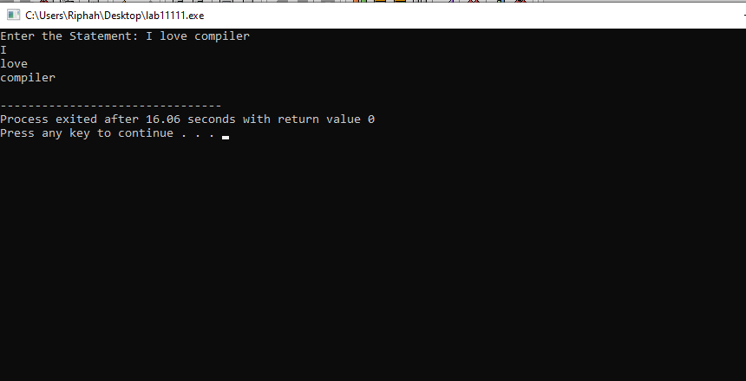
Task # 02
#include <iostream>
using namespace std;

int main() {
string input;
cout << "Enter a statement: ";
getline(cin, input);

string token = "";

for (int i = 0; i <= input.length(); i++) {
if (i < input.length() && input[i] != ' ') {
token += input[i];
} else {
if (token == "int" || token == "float")
cout << token << " Keyword\n";
else if (token == "+" || token == "=")
cout << token << " Operator\n";
else if (token != "" && token[0] >= '0' && token[0] <= '9')
cout << token << " Number\n";
else if (token != "")
cout << token << " Identifier\n";

token = "";
}
}

return 0;
}
Output:
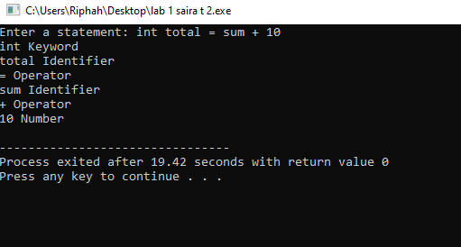

Task # 03
#include <iostream>
#include <string>
using namespace std;

int main() {
string input;
cout << "Enter the Statement: ";
getline(cin, input);

string token = "";

for (int i = 0; i <= input.length(); i++) {
// Build token until space or end of string
if (i < input.length() && input[i] != ' ') {
token += input[i];
} else {
if (token != "") {

if (token == "int" || token == "float" ||
token == "if" || token == "while" || token == "for")
cout << token << " : KEYWORD\n";

else if (token == "+" || token == "=")
cout << token << " : OPERATOR\n";

else if (token == ";")
cout << token << " : TERMINATOR\n";

else if (token[0] >= '0' && token[0] <= '9')
cout << token << " : NUMERIC\n";

else
cout << token << " : IDENTIFIER\n";

token = "";
}
}
}

return 0;
}
Output:
